A Progress Report

on

MUJ CAB SHARING APP

carried out as part of the course CSE CS3270 Submitted by

Shivam Agrawal

209302215

VI-CSE-D

in partial fulfilment for the award of the degree

of

BACHELOR OF TECHNOLOGY

In

Computer Science & Engineering



Department of Computer Science & Engineering,
School of Computing and IT,
Manipal University Jaipur,
March 2023

Acknowledgement

This project would not have completed without the help, support, comments, advice, cooperation and coordination of various people. However, it is impossible to thank everyone individually; I am hereby making a humble effort to thank some of them.

I acknowledge and express my deepest sense of gratitude of my internal supervisor Ms Deepti Sharma for her constant support, guidance, and continuous engagement. I highly appreciate her technical comments, suggestions, and criticism during the progress of this project “MUJ CAB SHARING APP”.

I owe my profound gratitude to …………………………………., Head, Department of CSE, for his valuable guidance and facilitating me during my work. I am also very grateful to all the faculty members and staff for their precious support and cooperation during the development of this project.

Finally, I extend my heartfelt appreciation to my classmates for their help and encouragement.

Registration No. Student Name
209302215 Shivam Agrawal



Department of Computer Science and Engineering
School of Computing & Information Technology

Date: 23 March 2023

CERTIFICATE

This is to certify that the project entitled “( MUJ CAB SHARING APP)" is a Bonafede work carried out as Minor Project Midterm Assessment (Course Code: CS3270) in partial fulfilment for the award of the degree of Bachelor of Technology in Computer Science and Engineering, under my guidance by ( Shivam agrawal ) bearing registration number(_209302215_), during the academic semester VI of year 2022-23.

Place: Manipal University Jaipur, Jaipur

Name of the project guide: Ms Deepti Sharma

Signature of the project guide: ______________________

MINOR PROJECT PROGRESS REPORT GUIDELINES

Contents
Page No.
Cover page

Certificate
Abstract

Table of Contents (with page nos)

- Introduction
  - Objective of the project
  - Brief description of the project
  - Technology used
    - H / W Requirement
    - Software Requirement
  - Organization Profile (if applicable)
- Design Description
  - Flow Chart
  - Data Flow Diagrams(DFDs)
  - Entity Relatoinship Diagram(E-R Diagram)
- Project Description
  - Data Base
  - Table Description
  - File/Database Design
- Input/Output Form Design
- Future scope
- Conclusion
- Bibliography

Objective
The Cab Sharing application will provide a platform for users to book cabs on their preferred routes so that their fare can be minimized.

Brief Description

The Cab Sharing application will provide a platform for users to book cabs on their preferred routes. The application will allow users to create a profile and make their booking, it will also allow drivers to make their profiles and accept the bookings
The application consist of the following modules
- User Profile Creation
Users will be able to create a profile on the portal, including their personal information and address
- Map Screen
It will detect the current location of the user and then take user input from the declared list for the destination
- Cab selection
After selecting the destination, the user will be able to select the preferred cab by comparing the routes and fares
- Ride booking confirmation
Once the cab is selected the user is given a confirmation of their ride by sharing the cab number and the driver details
- Review System
After the ride is completed, the user is required to give the feedback of their ride in order to eliminate poor drivers from the app and appreciate good drivers

Technology Used
1.3.1 Hardware Requirements-
- Android version 5.1
- Ram 2GB
- 45 MB of free disk space

1.3.2 Software Requirements-
- Flutter 3.0
- Dart 3.0

2 .Technology Used
- Data Flow Diagram
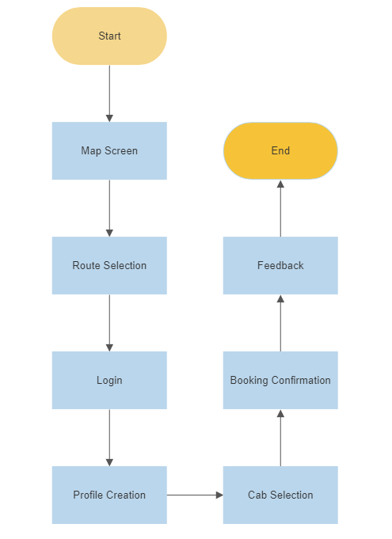
- Entity Relatoinship Diagram(E-R Diagram)
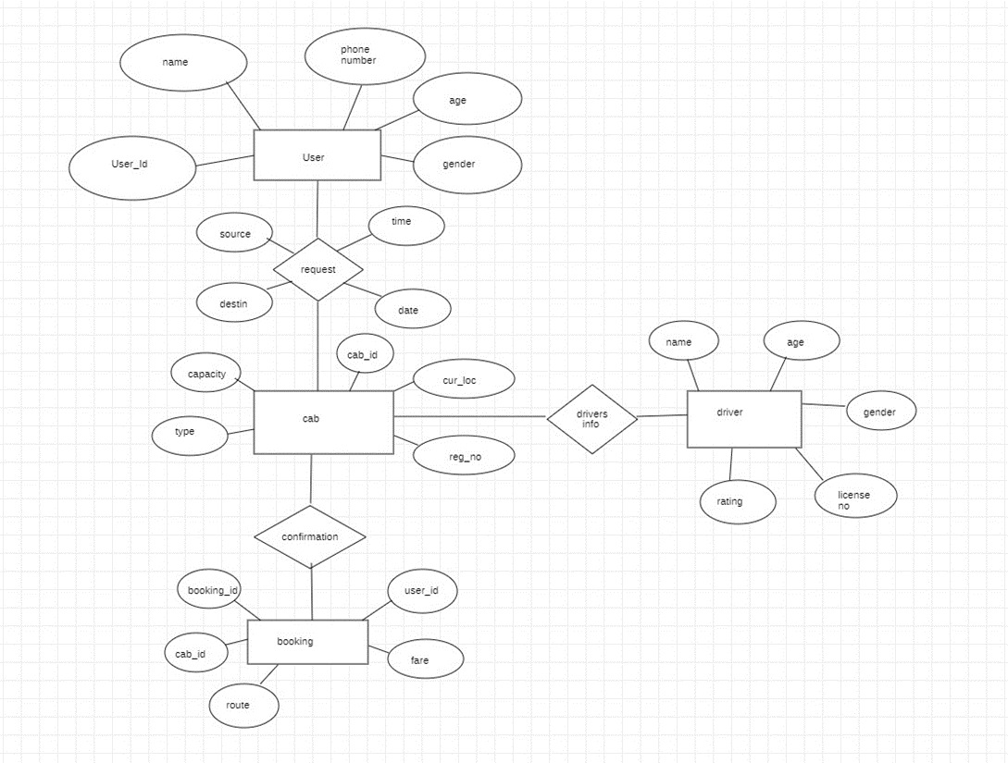

Project Description
3.1 Data Base
  - Firebase
  - Table Description
  - File/Database Design
  - Login details
  - Cab details
  - Ride details

Input/Output form design
- Map Screen
- Route Selection
- Login Screen
- Profile Creation
- Booking Confirmation
- Feedback

Future Scope
- Driver Profile Creation
- Custom Route request
- Carpool
- Driver recommendation system
- Route declaration by drivers
- Payment gateway

Conclusion
- The Cab Sharing application will provide a platform for users to book cabs on their preferred routes so that their fare can be minimized
- The application will comply with all relevant privacy and security regulations and laws to protect the personal information of users and drivers.

Bibliography

https://flutter.dev
- https://pub.dev
- https://develepors.google.com
- Udemy- Flutter and Dart - The complete guide

